**Pre-requisites for setting up site on Local Machine:**

* ***Install and Configure ‘Local by Flywheel’:***

**Installation Steps:**

1. Go the link <https://localwp.com/> and click on download in the top right corner.

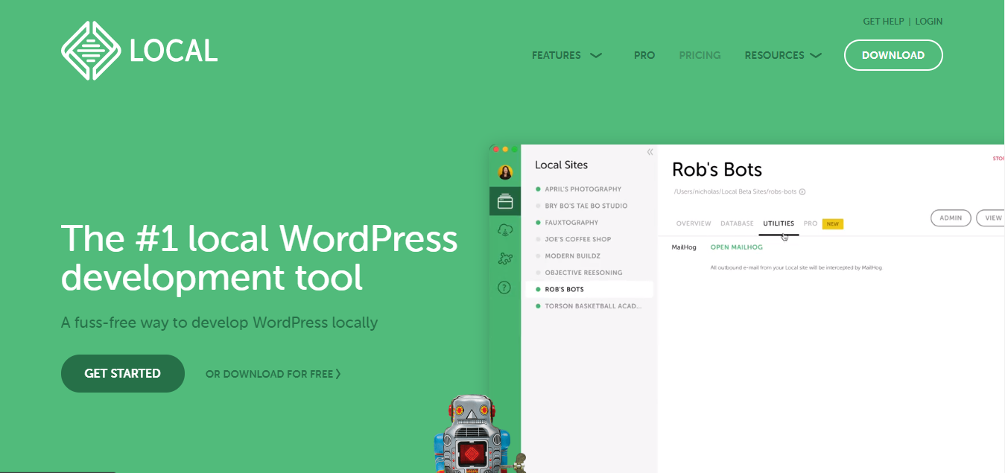

1. Select the Platform.

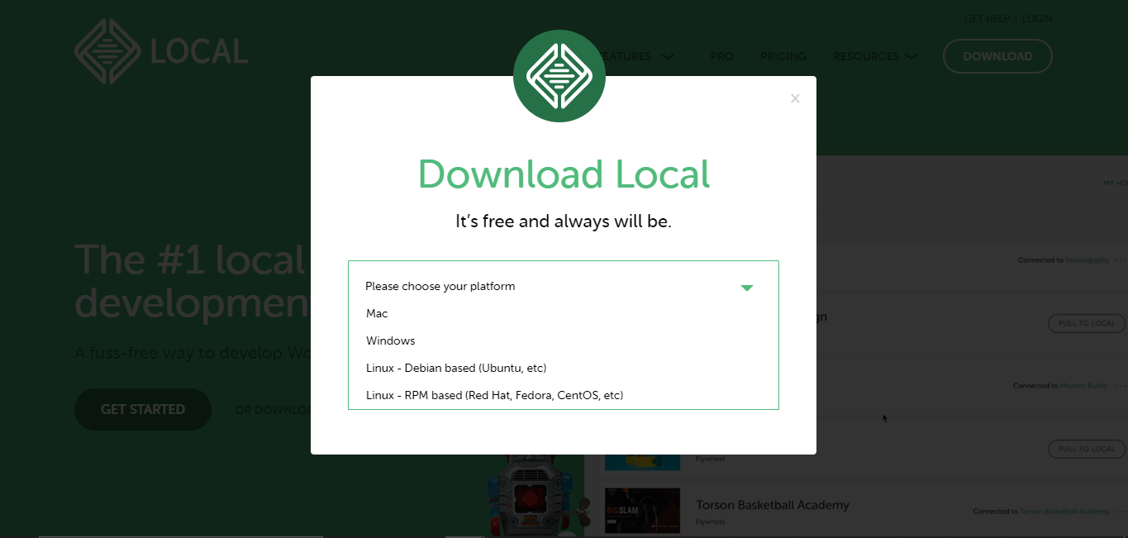

1. Enter all the details mentioned in form and click on ‘GET IT NOW’.

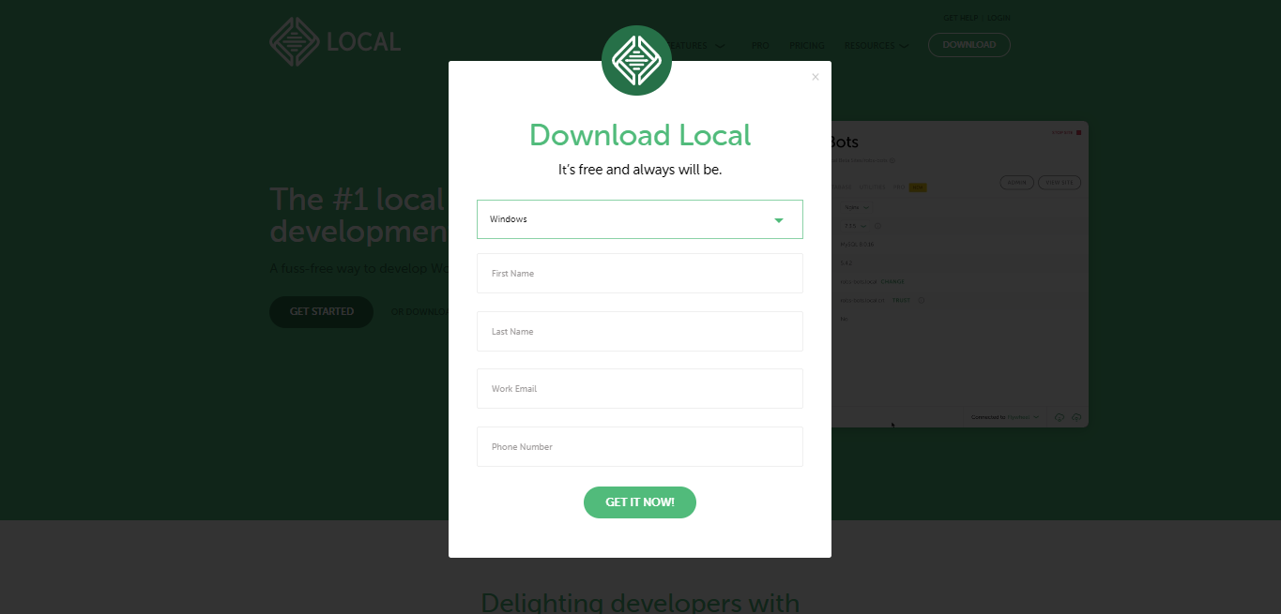

1. Automatic download should start.

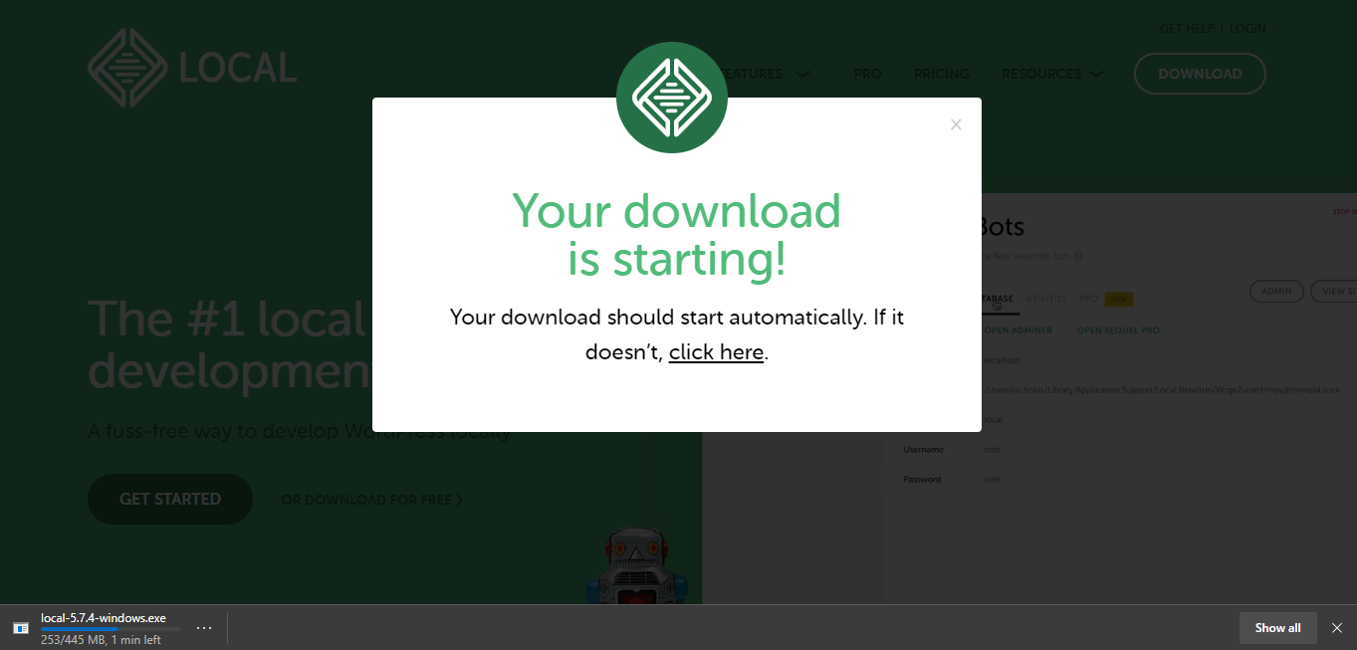

1. Run the Exe file which is downloaded to your downloads folder.

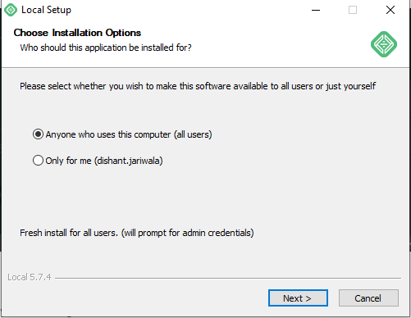

1. Select the folder where you want to install ‘local by flywheel’ and start the installation.

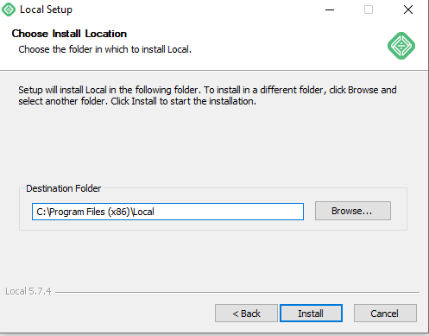

**Configuration Steps:**

1. Open the 'Local by Flywheel’ app and click on ‘CREATE A NEW SITE’.

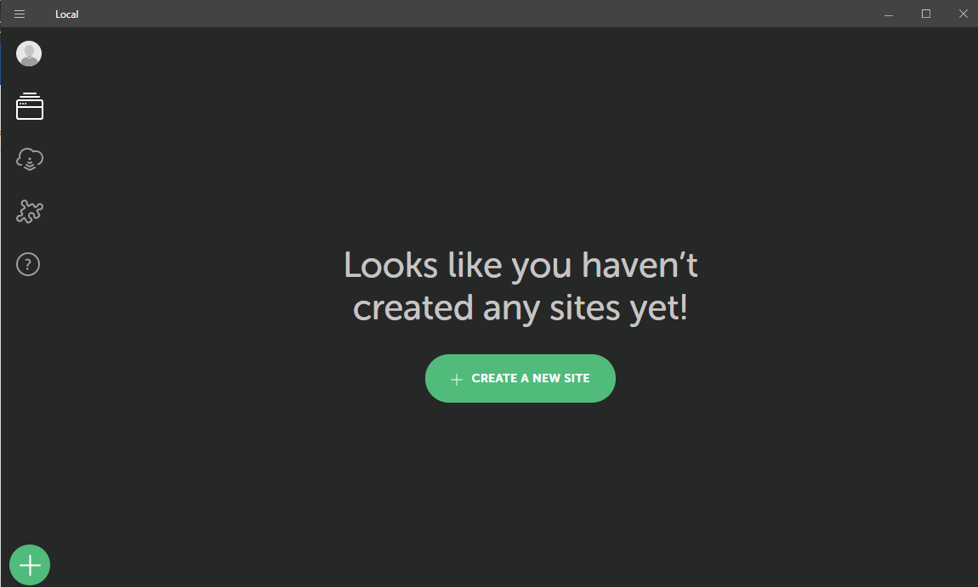

1. Enter any name for your site and click on Continue.

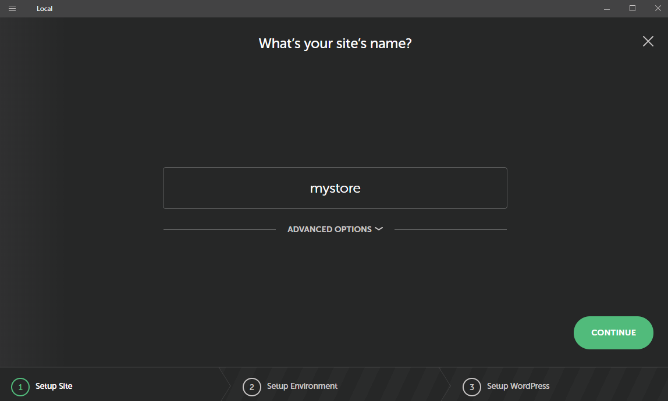

1. Select Preferred Environment and click on Continue.

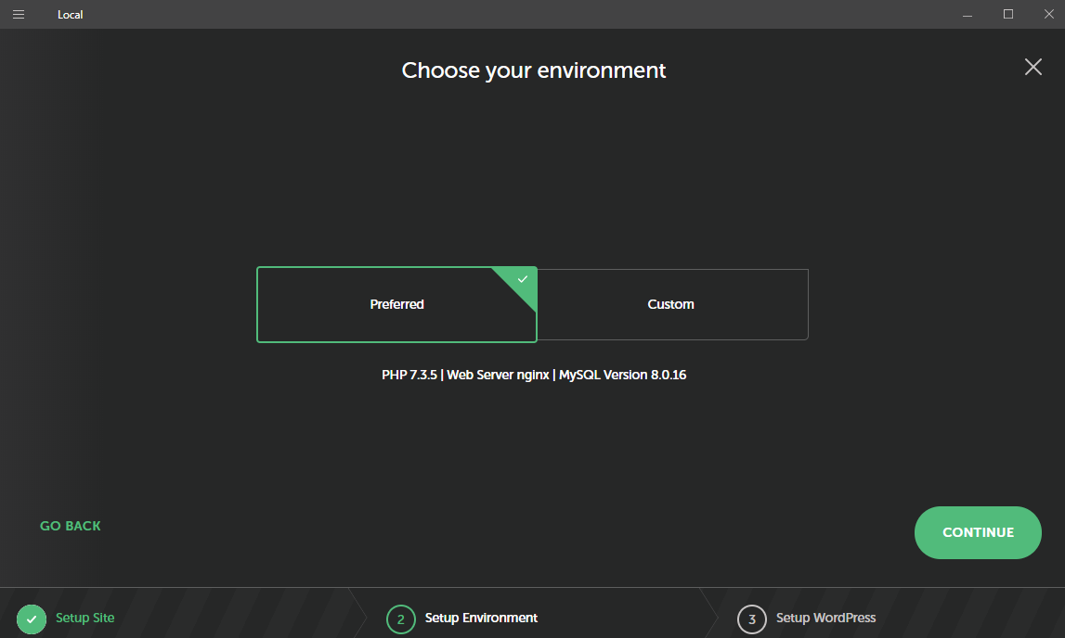

1. Enter WordPress Username, Password and Email and Click on ‘Add Site’.

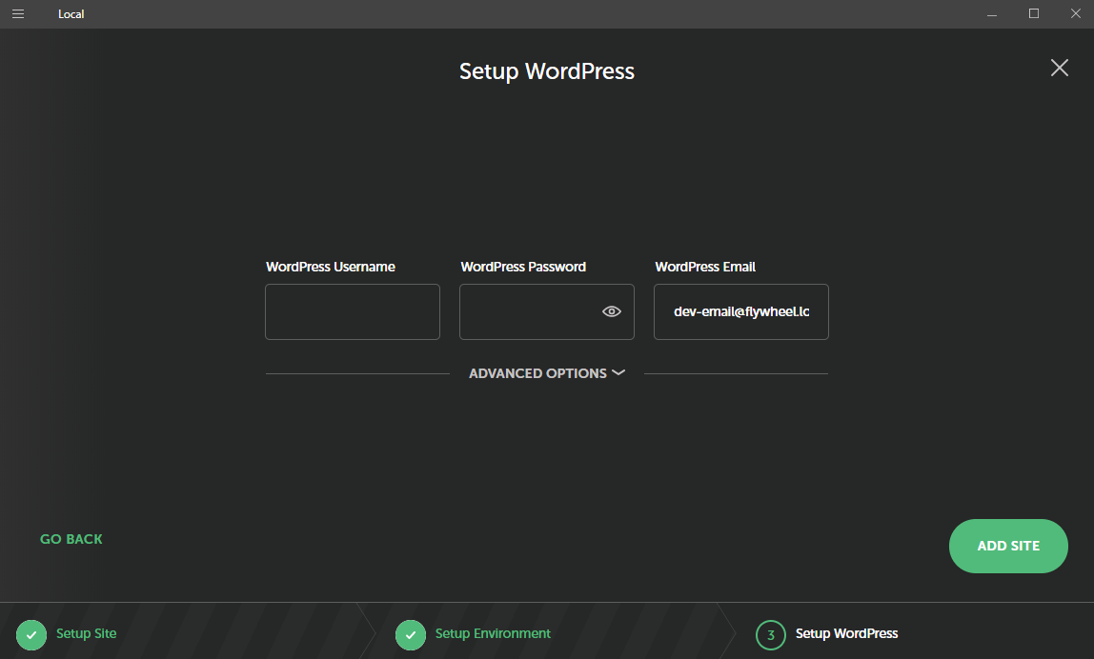

1. The details of your site will be visible as below.

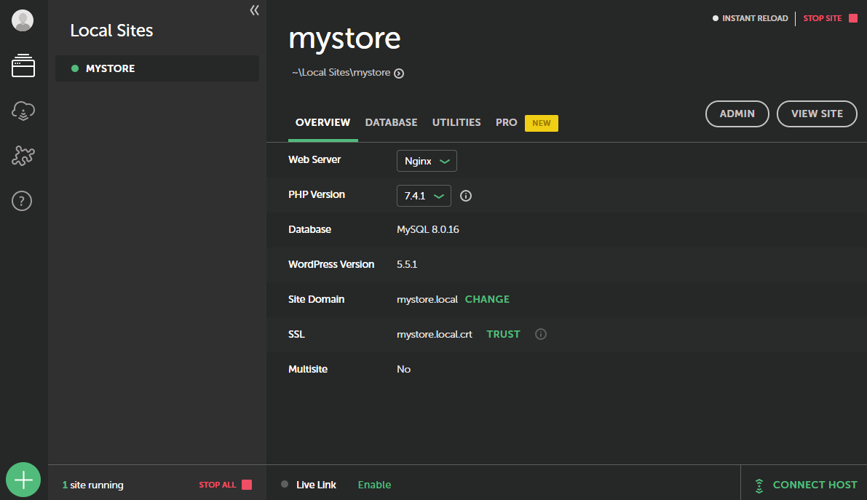

Database details:

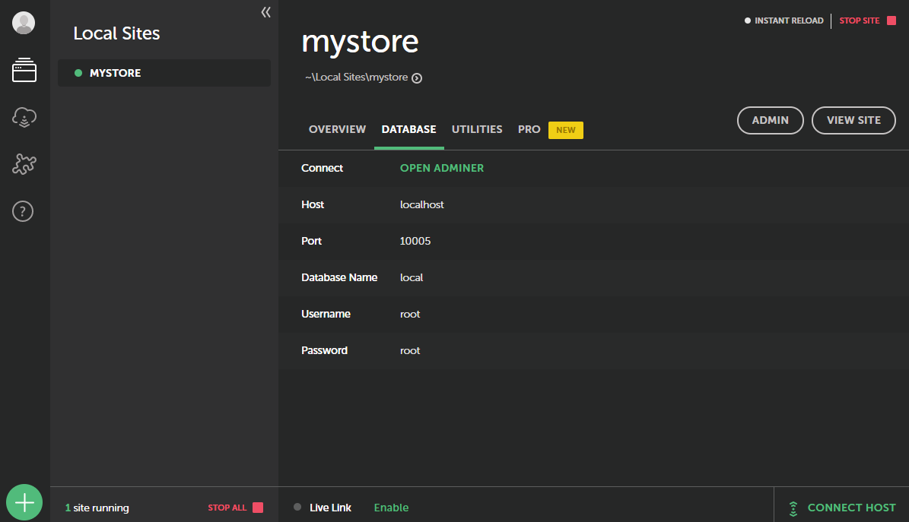

1. Your WordPress and “Local by Flywheel” setup has been successfully done.

* ***Configure WordPress site:***

**Configuration Steps:**

1. Open the Admin dashboard by clicking on the top right “Admin” button in “Local by Flywheel” app, then you’ll be redirected to the below page.

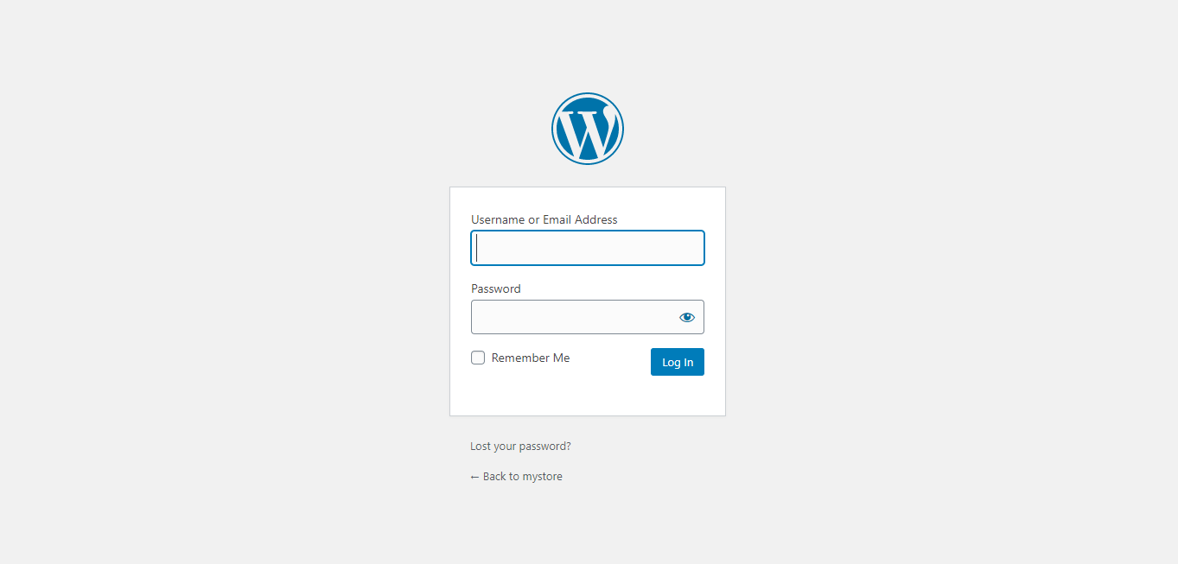

1. Enter you credentials which you gave entered in Step 4 of configuration for “Local by flywheel” and click Log in.
2. Now, on the left pane, go to Appearance > Themes.

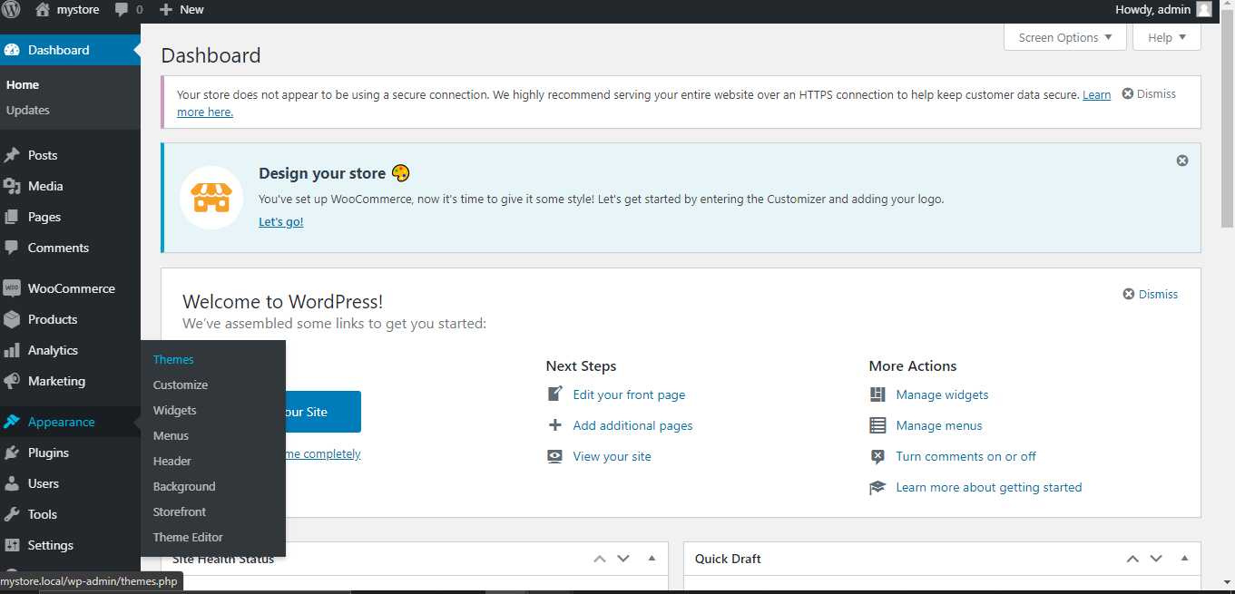

1. Click on “Add New” button on top.

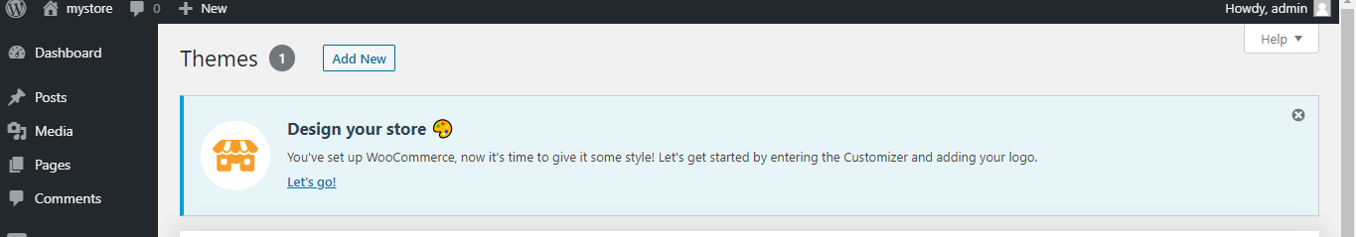

1. Now, search for “storefront” in search box and download and activate the first theme as displayed below.

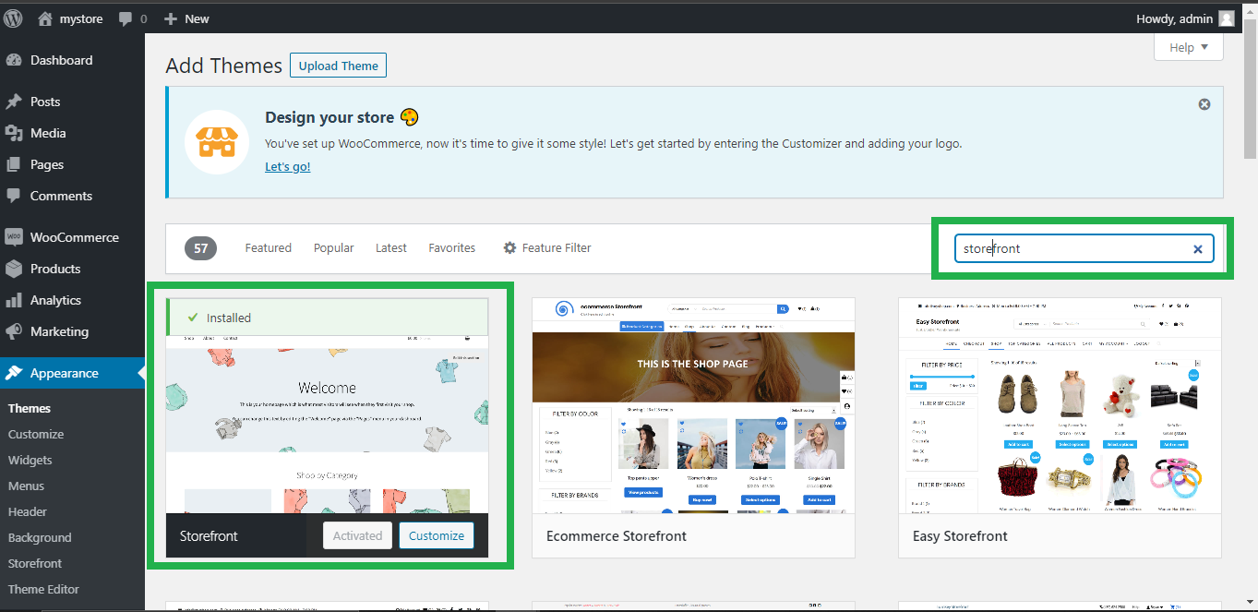

1. Now, go to Plugins > Add New.

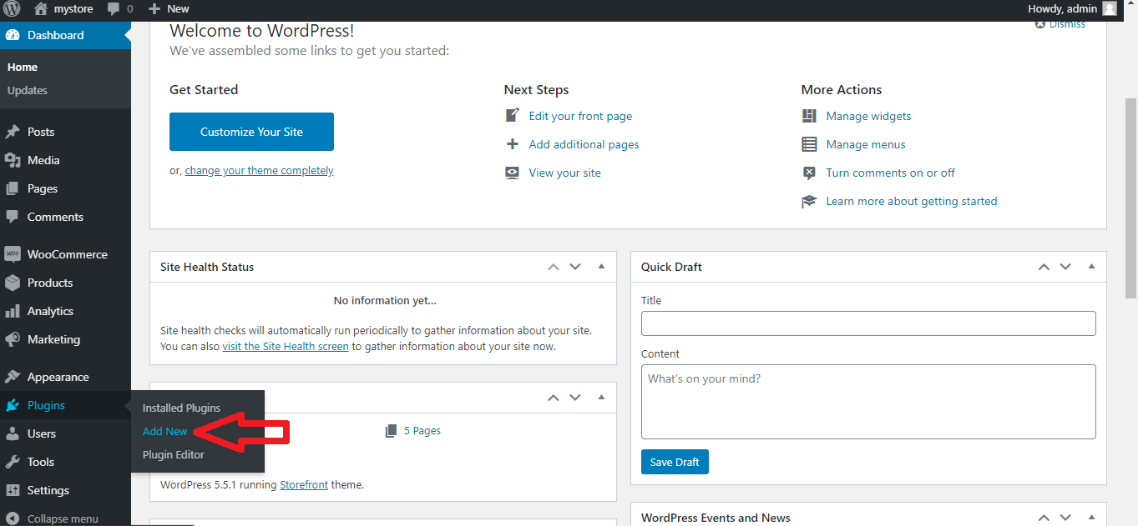

1. Now, search for WooCommerce and install the plugin and activate it.

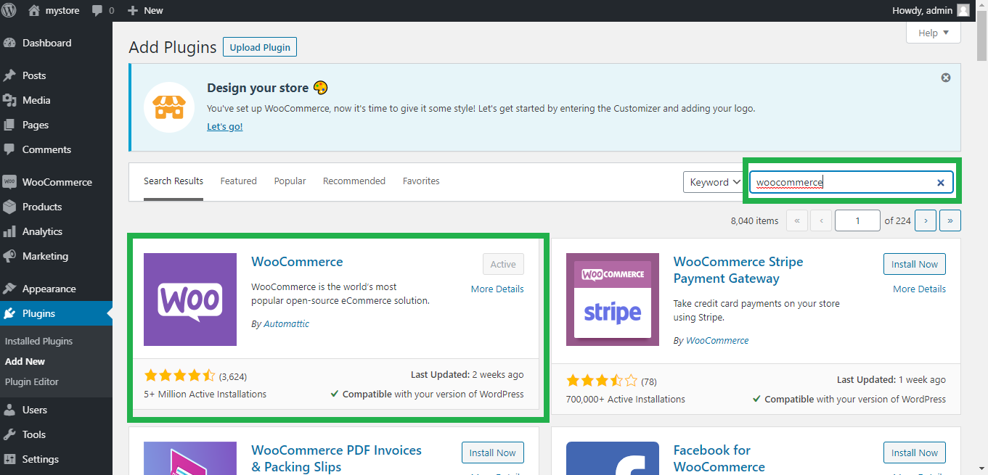

1. Now open by setup wizard by going to WooCommerce > settings, now click on help on the top right and then go to setup wizard and click on “setup wizard”.

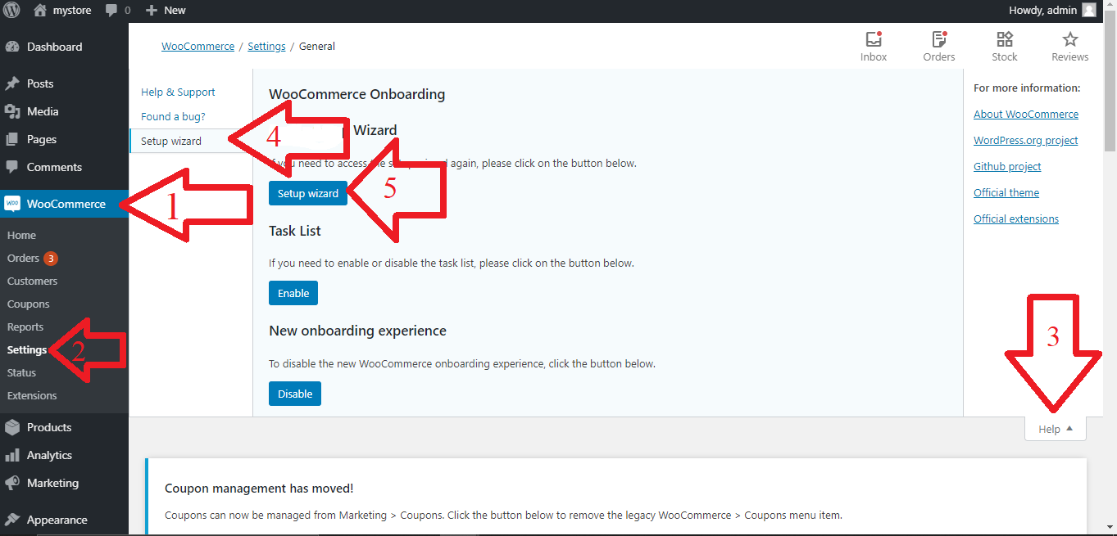

1. Now, fill the address details in setup form as displayed below and click on continue and then click continue on the Pop-Up.

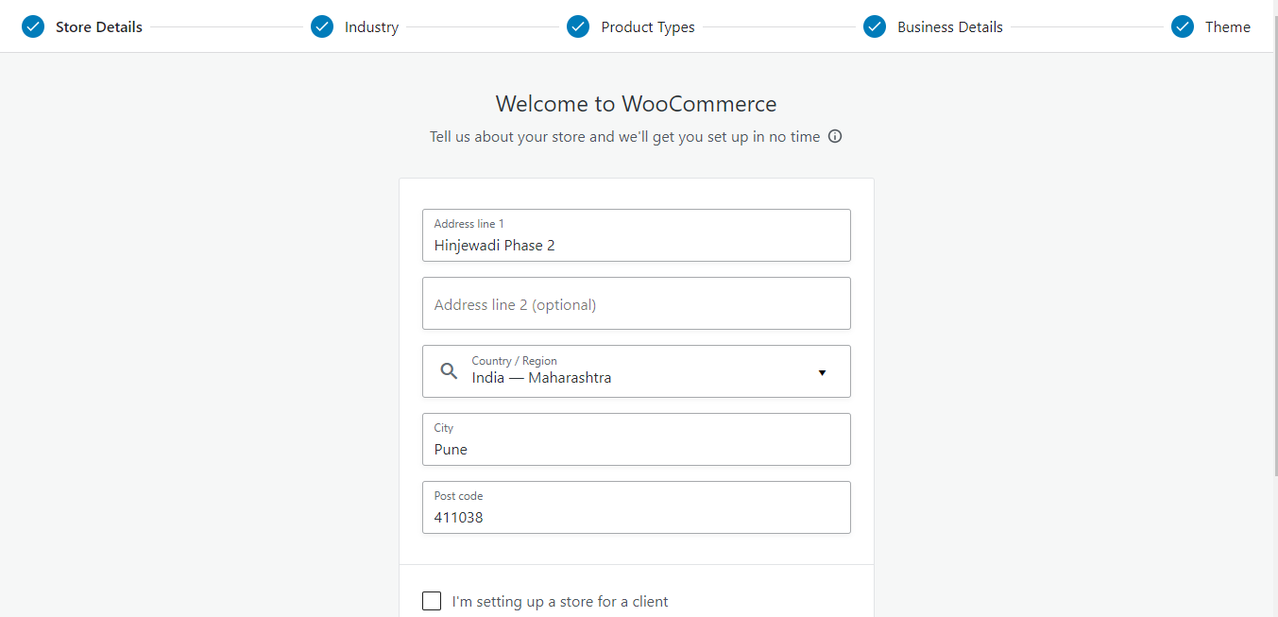

1. Select the value in the next screen as displayed below and toggle all the buttons to OFF.

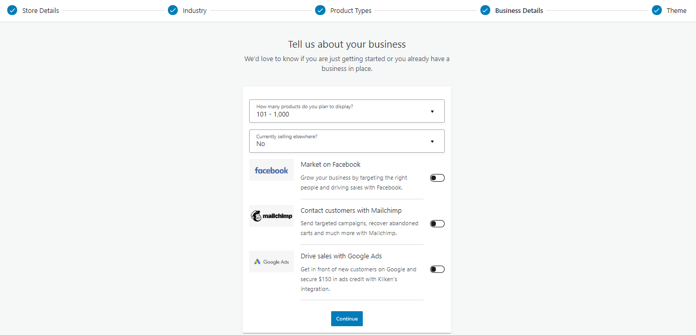

1. Now select the theme as “storefront” in the next screen.
2. Visit the <http://mystore.local/> to check if the site is being loaded.

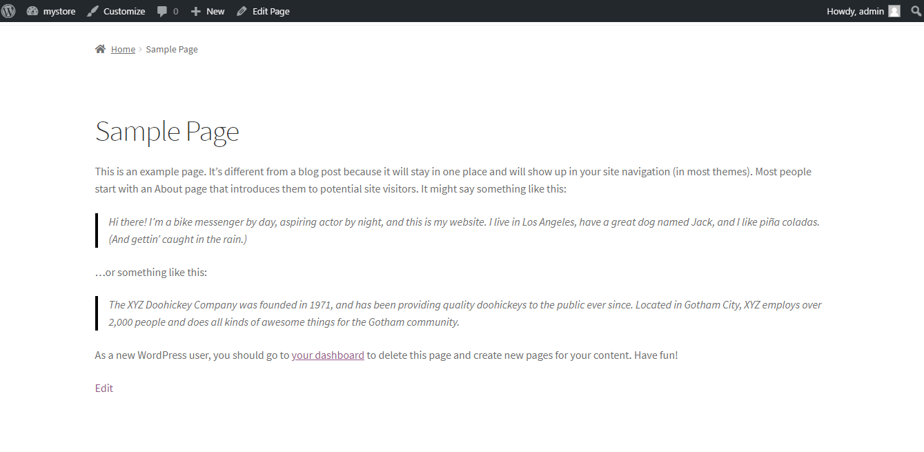

1. Now add WooCommerce sample products in a following way, search “WooCommerce sample products” in Google search bar and go to the following link.

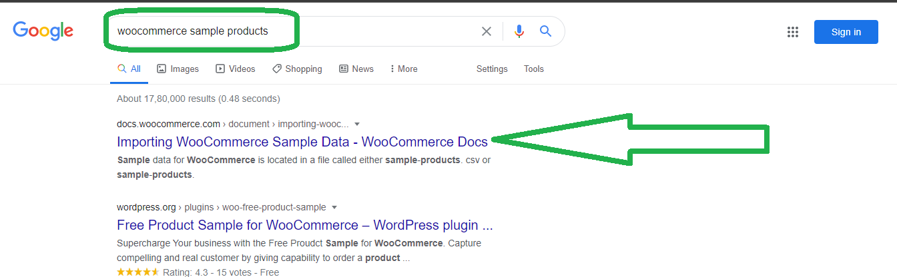

1. Click on Re-download “WooCommerce” by clicking the link.

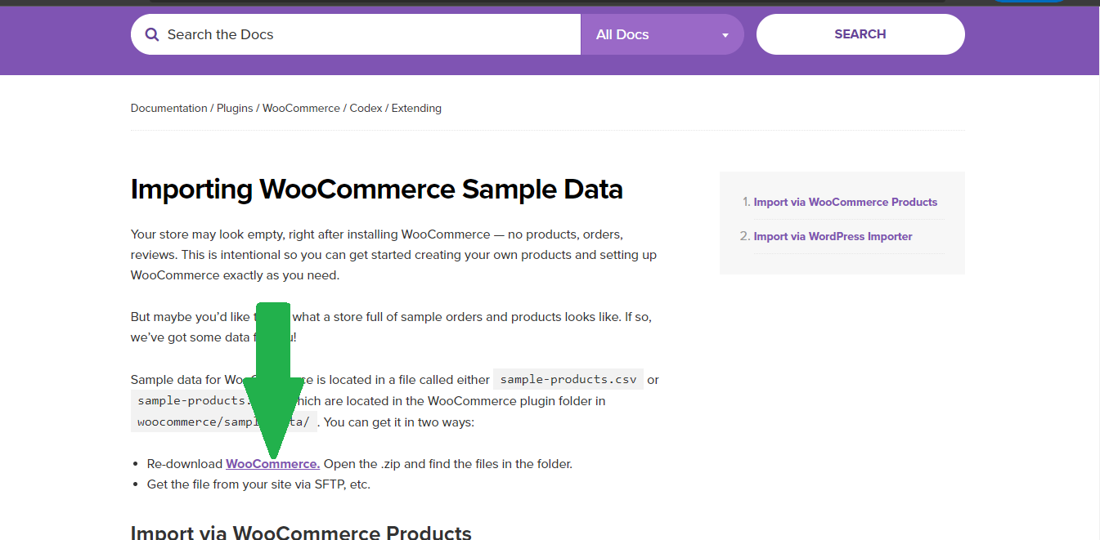

1. You'll be redirected to WordPress site, now click on download button and wait for the woocommerce.zip file to be downloaded to your machine.

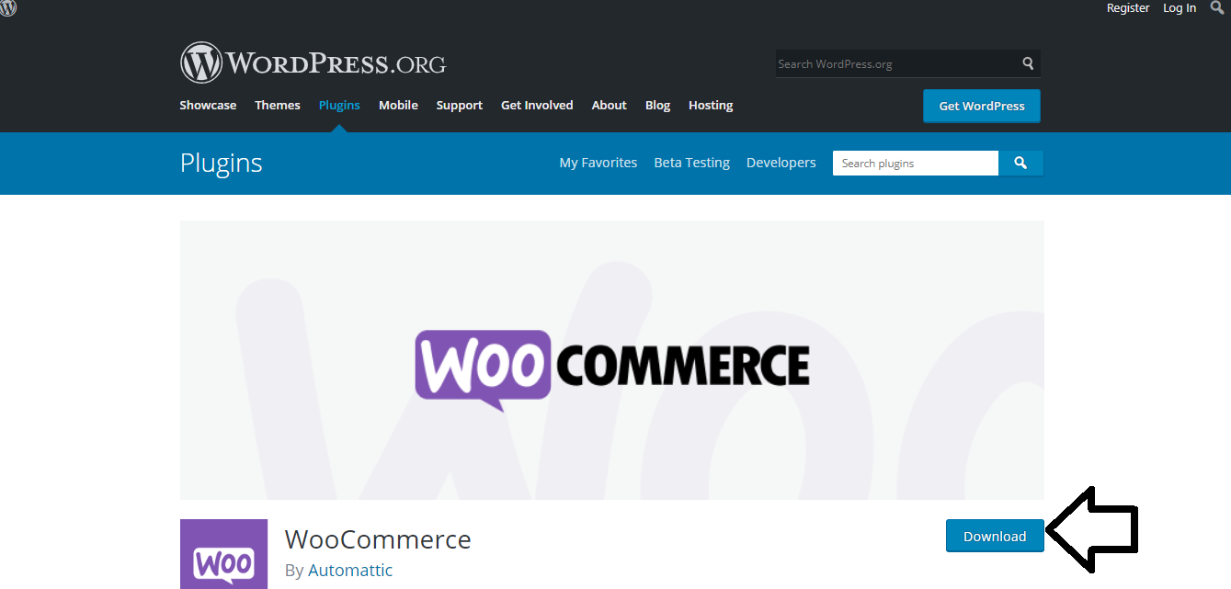

1. Extract the woocommerce.zip file to your preferred folder on your machine.



1. Now, to import the products to your site, go to the WordPress admin site on your browser by entering the URL: <http://mystore.local/wp-admin> and then go to Tools > Import.

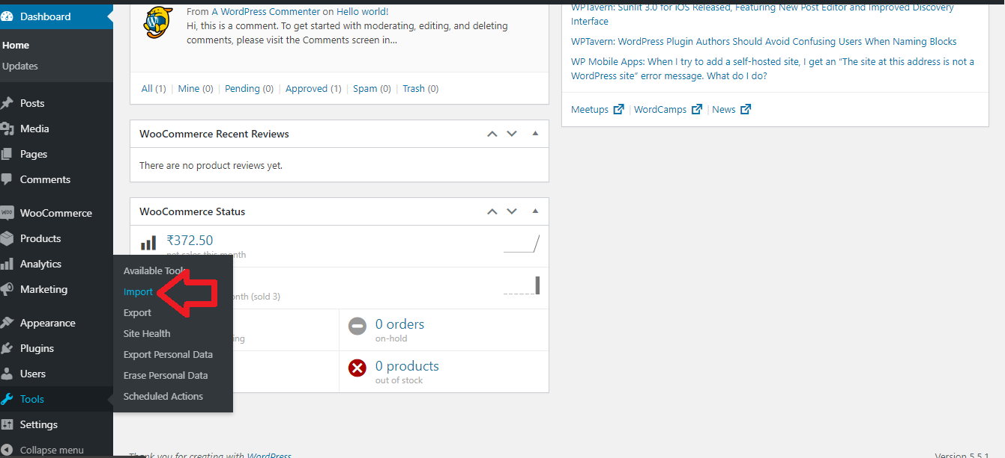

1. From the list, install the WordPress Importer by clicking on install now and then click on Run Importer.

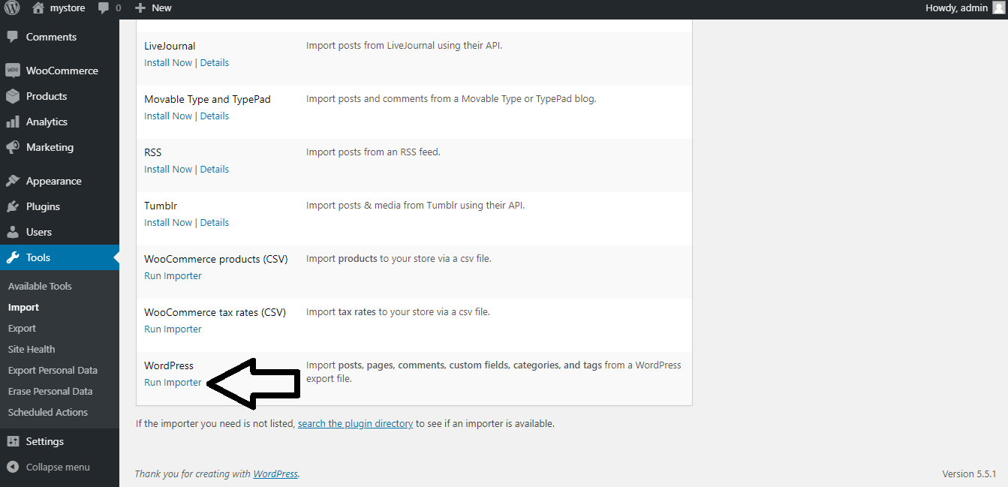

1. Now, click on choose file and choose the file, As shown in the next step.

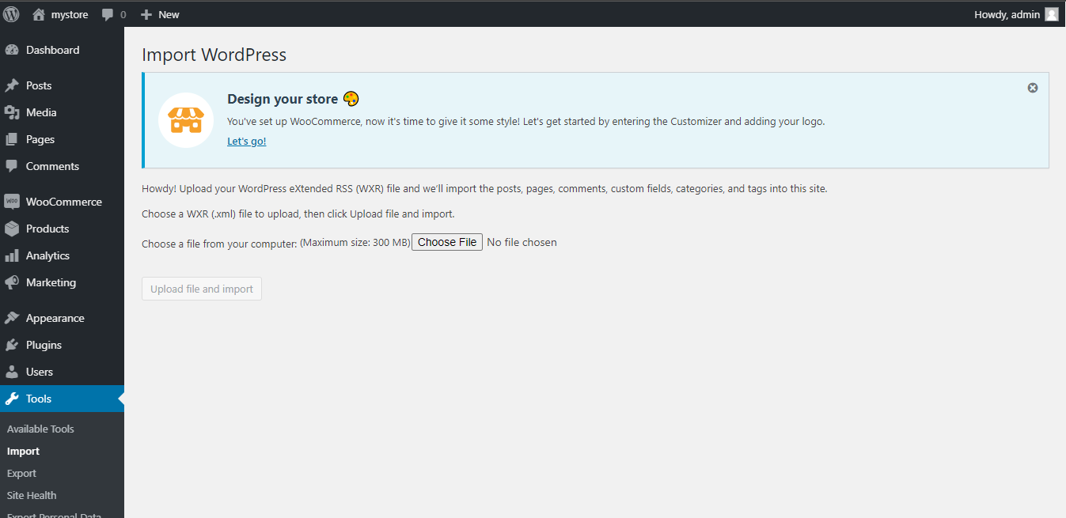

1. Now, choose the file sample_products.xml in the explorer from the folder extracted by woocommerce.zip file by navigating to woocommerce > sample-data.



1. Select the Check Box and Click on Upload file and Import.

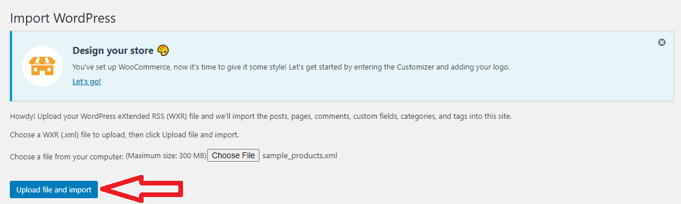

1. Now go to <http://mystore.local/shop> to see if the products are being added.

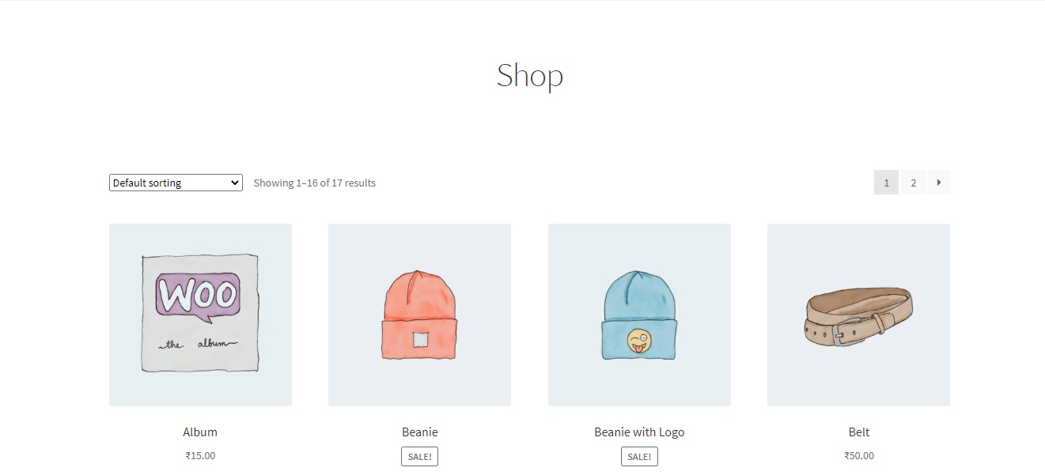

1. Now configure the website by going to WordPress admin site using the URL: <http://mystore.local/wp-admin> and then navigate to Settings > Reading from the left pane.

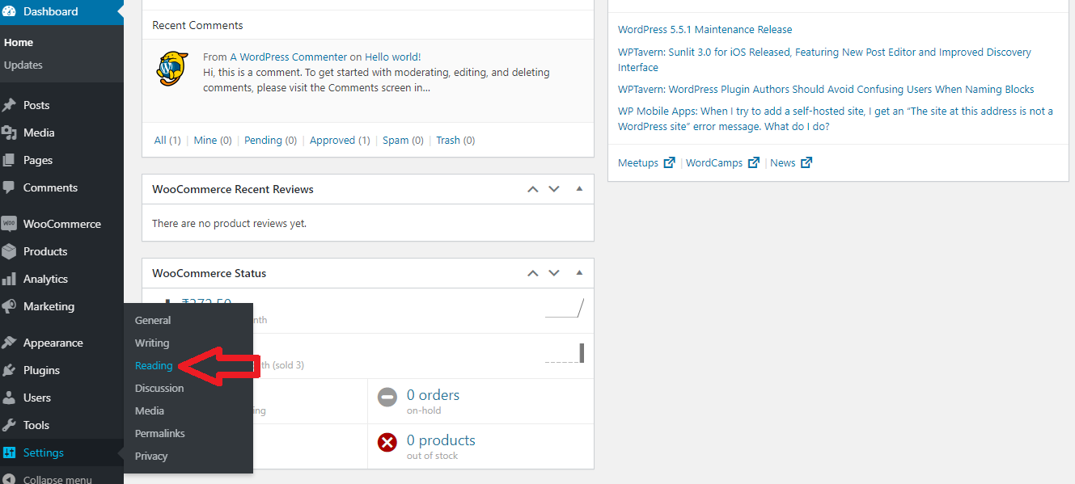

1. Select Static Page radio button and then select shop from Homepage dropdown and then click on Save Changes at the bottom of the Reading Settings page.

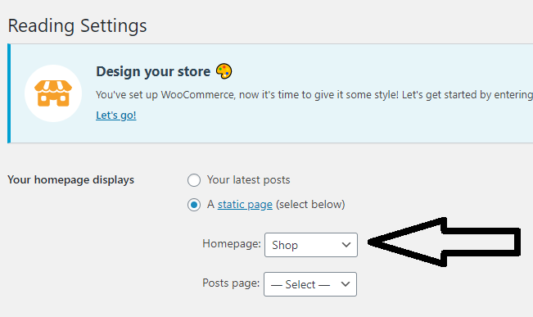

1. Now, go to WooCommerce > Settings from the left pane and select the Shipping tab and click on “Add shipping zone”.

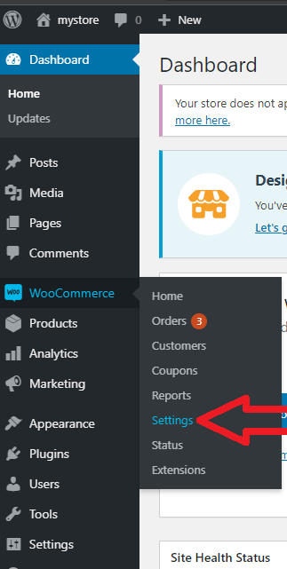

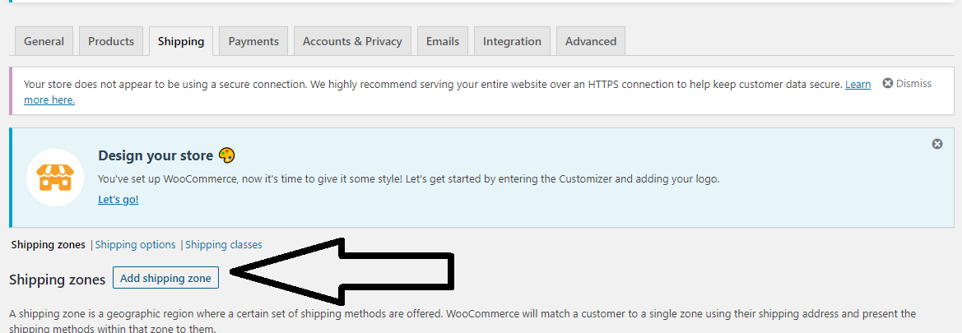

1. Now enter the following values in the Add shipping and then click on “Add shipping method button”.

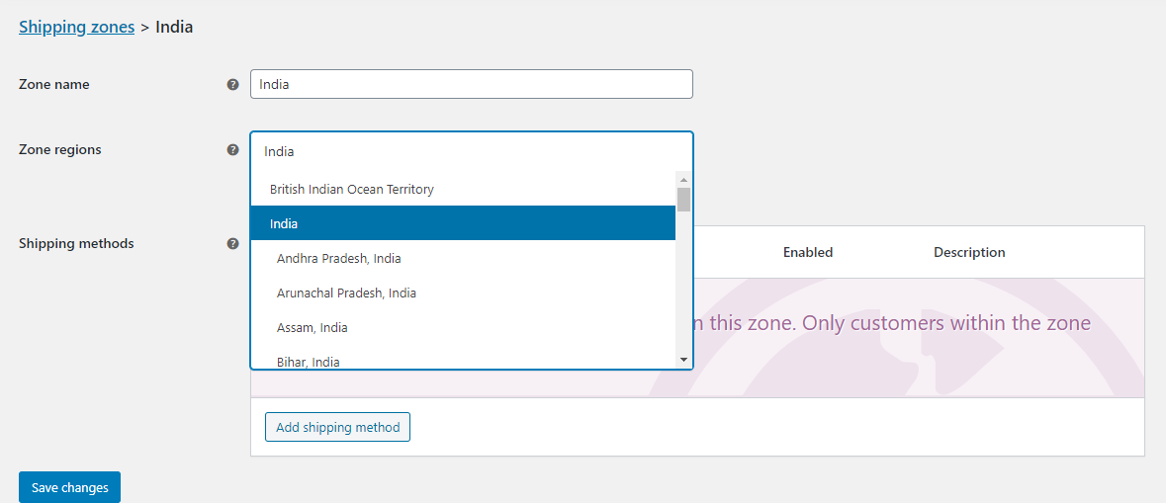

1. Select “Free shipping” from the drop down and then click on Add shiping method.

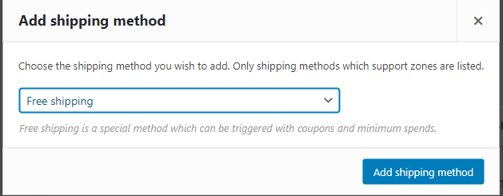

Now follow the same procedure but this time select “Flat Rate” from the Add shipping method drop down:

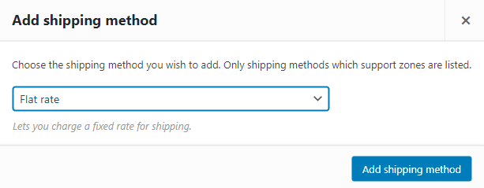

Now edit the flat rate shipping method and then change the “cost” field to amount as preferred

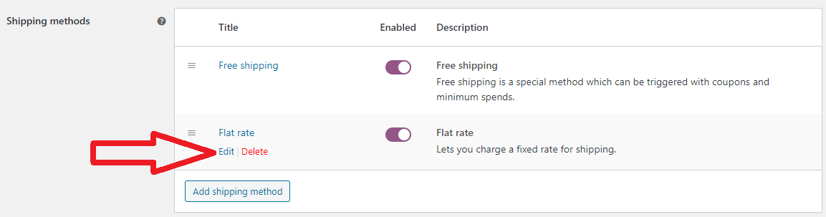

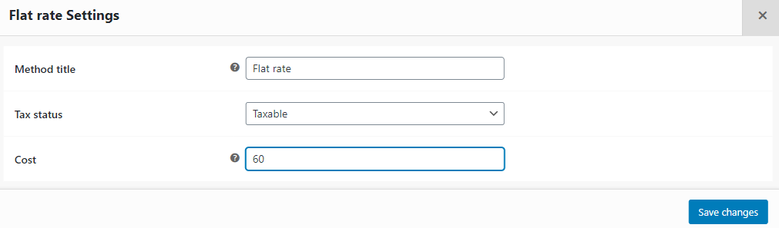

1. Navigate to WooCommerce > Setting as shown in step 25 and then click on Payments tab and toggle Cash on delivery to ON and click on Save changes.

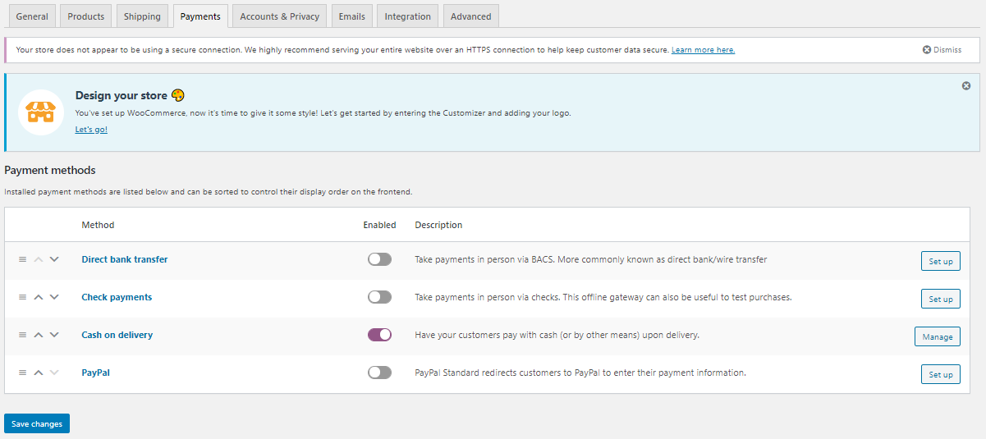

1. Now, click on “Accounts & Privacy” tab and check the boxes as below and click on save changes.

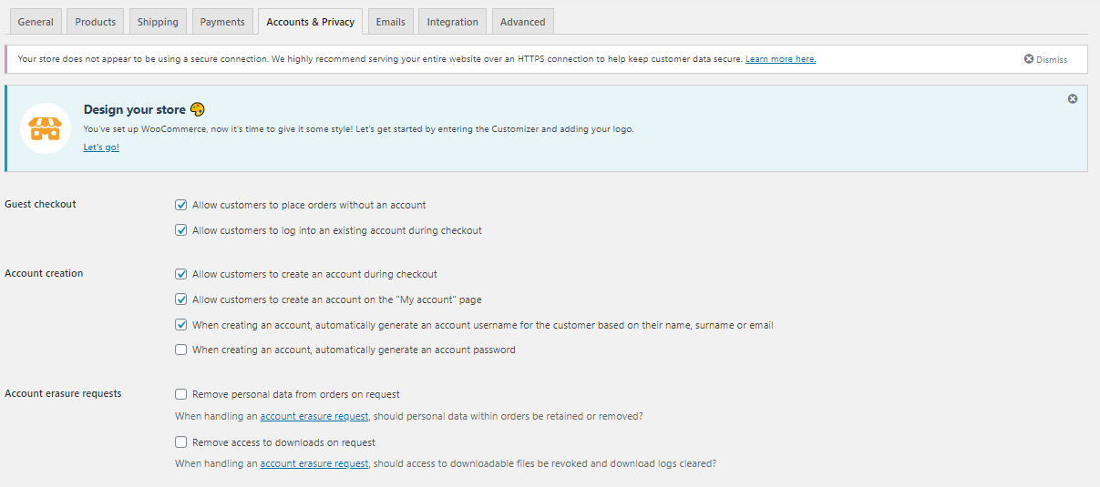

1. Now, click on “Advanced” tab and click on REST API.

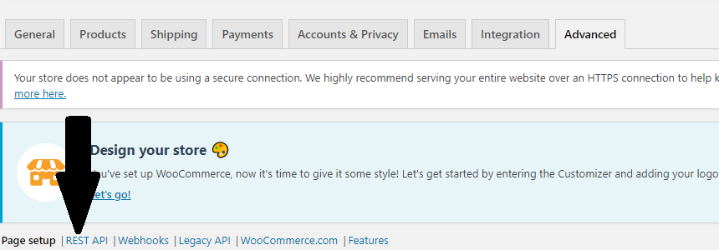

1. Click on Add key and select the following values for the field (NOTE-you can enter description as preferred) and click on “Generate API key”.

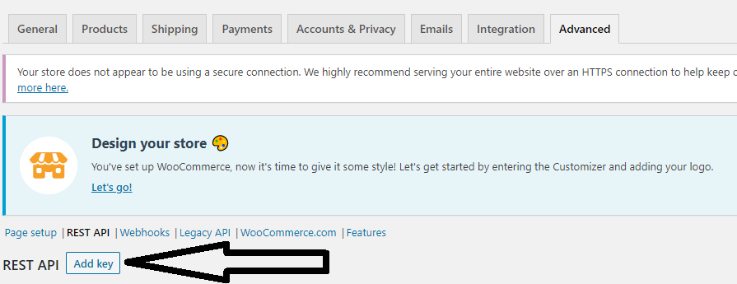

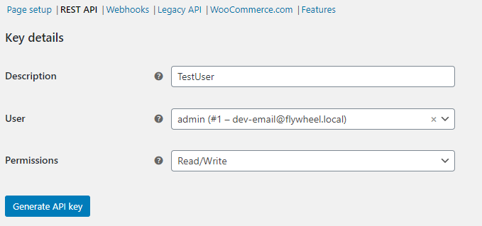

1. Save the Consumer Key and Consumer Secret to a notepad first for future use.

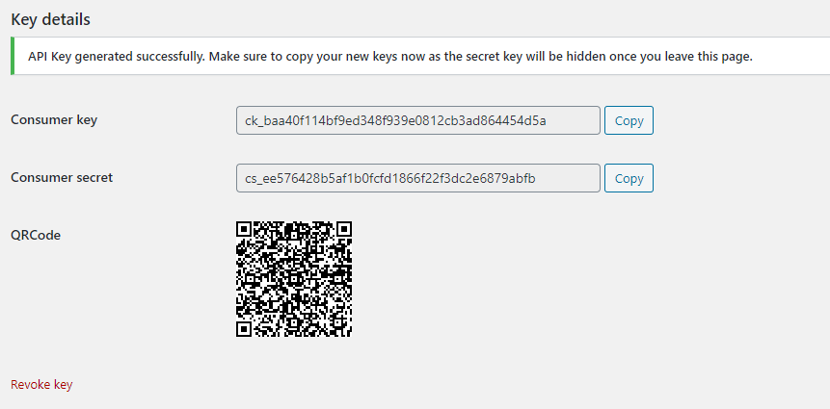

1. Add the consumer key and consumer secret in the system variable in a following way:

Click on New in environment variable and enter WC_KEY in variable field and the value of consumer key generated in step 32 as value. (similarly add WC_SECRET In same manner)

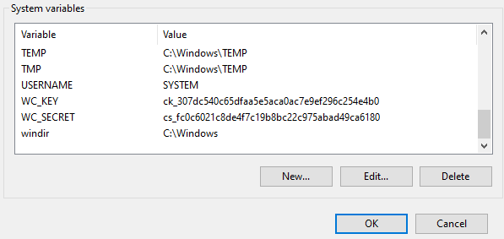

Click on New in environment variable and enter DB_USER in variable field and “root” as value. (similarly add BD_PASSWORD In same manner and keep the value same I.e. “root”)

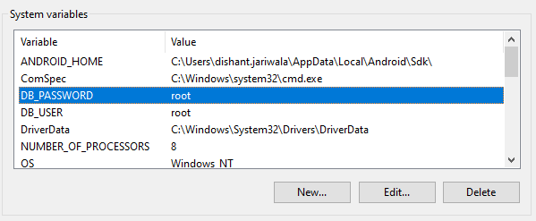

1. Now Restart your machine and you’re good to go!